EDUARDO ANTORAZ
FOTOGRAPHER / GRAFIC DESIGNER
Date of birth: 09-Enero-1974
Nationality: spanish
Málaga, Availability for work outside my country
Phone: 0034 629290680
contacto@fotografia-malaga.es

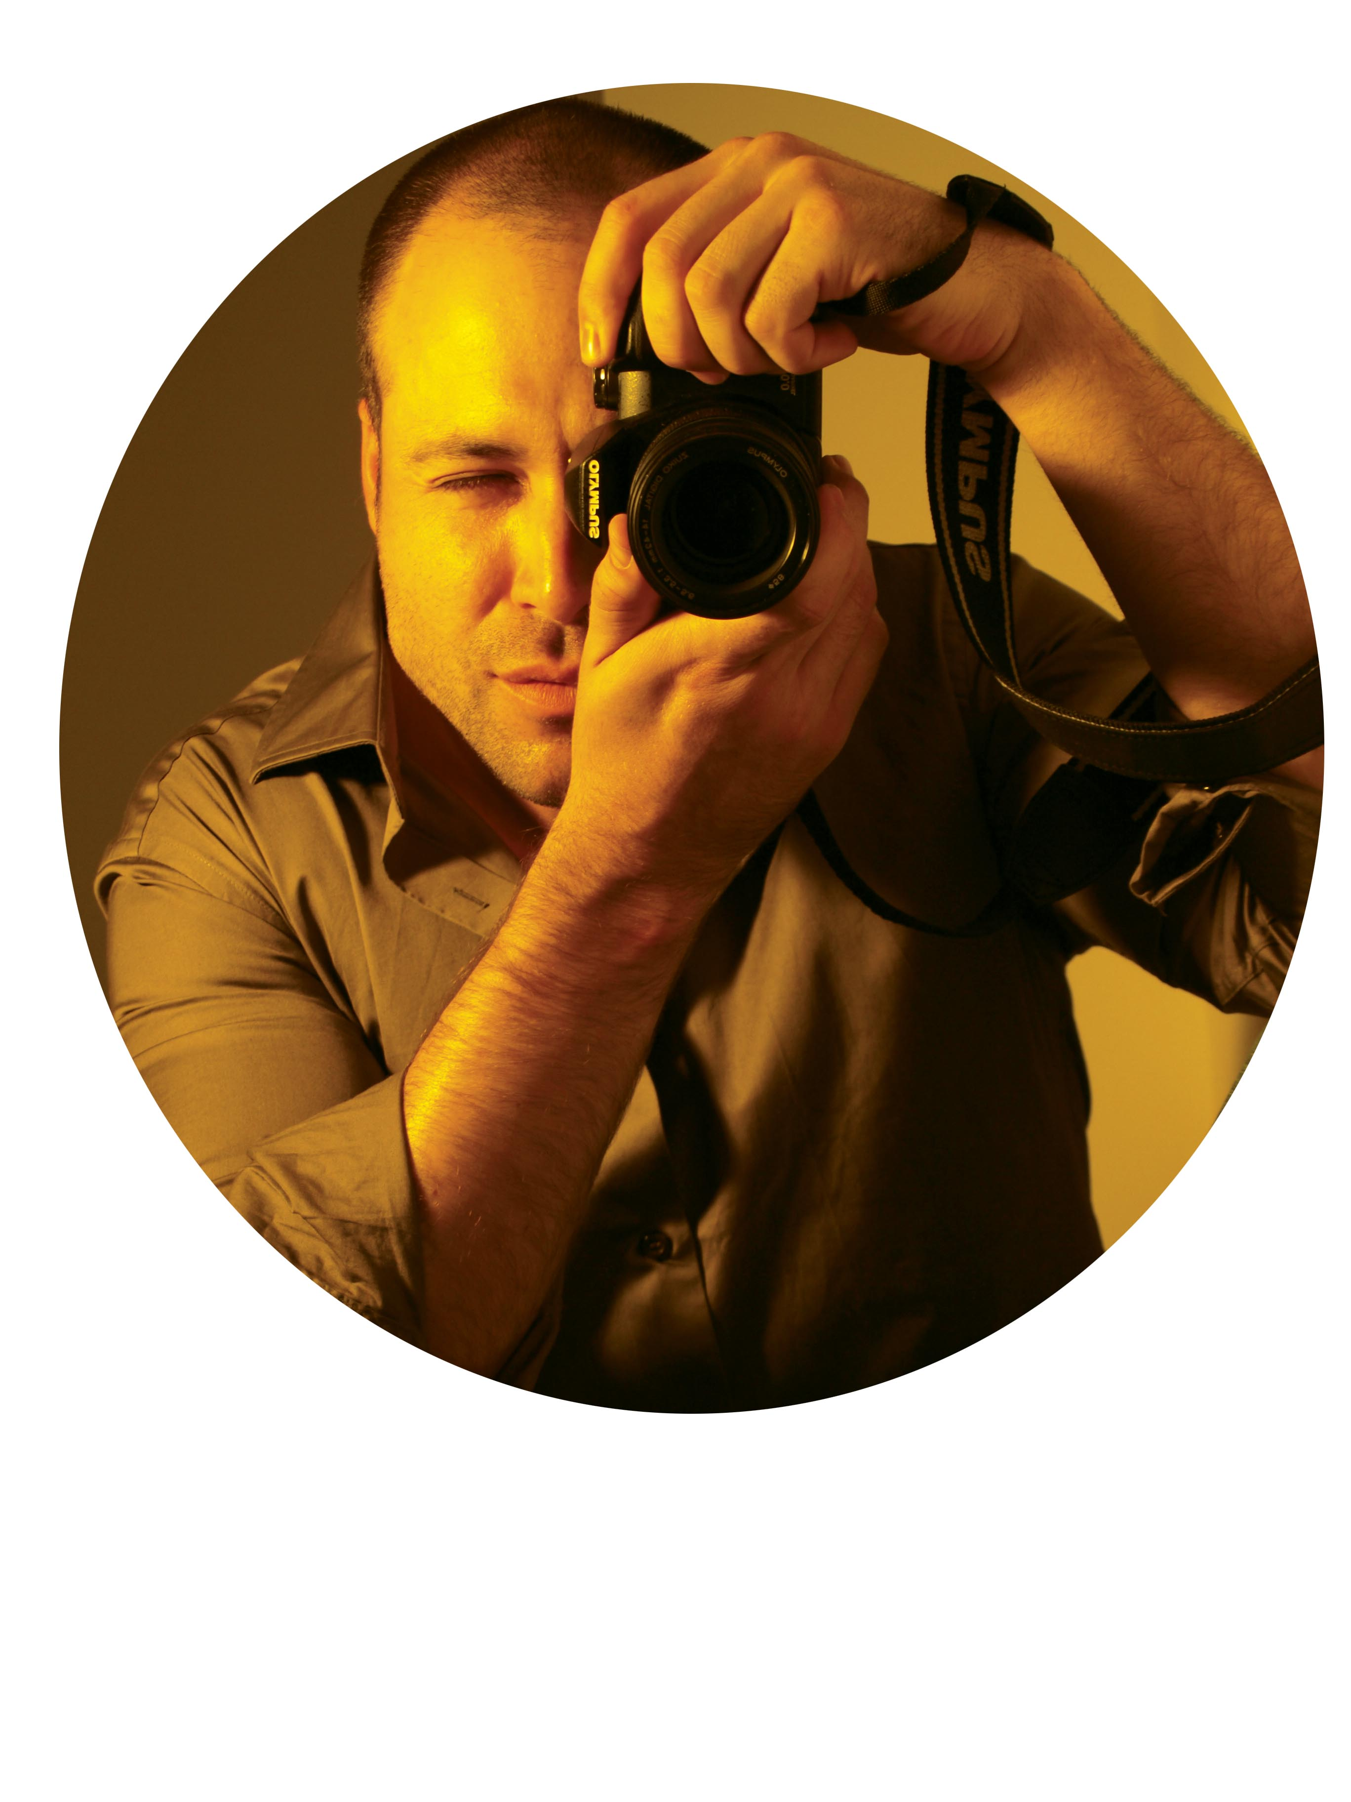

1995-2000: Fine Arts Degree
University of Salamanca
subjects:
painting
sculpture
Graphic Design Commercial
Technical Drawing
Specialty Graphic and Audiovisual Design (3 years)
(Packaging, Direct Marketing, Story Boards, Corporate Identity
Books, Layout and Typography)
Expert in Photoshop
Photography in White / Black and Rack (two years)
Marketing & Advertising
Domain design programs (freehand, quark xpress, photoshop)
Art and architectural space.

Experience Profesional:
- photographer/desinger www.fotografia-malaga.es
www.fotografia-inmobiliaria-malaga.es Málaga 2011- Now
- Stylist and Store Manager Carlo Pignatelli. Madrid Oct 07- Dic 10
- Store Manager and photographer Salvador Bachiller. Madrid Ago 04 - Ene 06
- Design and photography . Madrid Ago 04 - Ene 06
- Designer and photograper Edt Events. Madrid Mar 03 - Ago 03
- Art Director Senior in Consuldis. Madrid Feb 02 - Mar 03
- Art director senior in Below Marketing. Madrid Ene 01 - Nov 01
- Web designer, photographer in 121 GMC. Madrid Ago - Dic 00

       
Hobbies: photography, drawing, traveling, sports, gym
Languages​​: English (intermediate / high) and Spanish
My purpose is to acquire more and more experience photographer.
If you are interested in arranging an interview to know
and know my work please contact me via phone or email
Below I show a brief summary of my work, waiting
they are to their liking. .
Sincerely, Eduardo Antoraz

Examples 2017



